IGNACIO COMMUNITY LIBRARY
MEETING NOTICE/AGENDA
The Ignacio Community Library District Board of Trustees will conduct their regular meeting on March 31, 2026 at 4:15 p.m. at the Ignacio Community Library, 470 Goddard Ave. Ignacio, CO. Or via Zoom. The public is invited and encouraged to attend.

- Call to Order
- Roll Call
- Approval of Agenda
- Unfinished Business
  - Audit Exemption Request Approval
- Adjournment

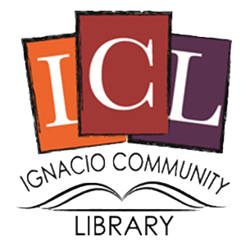
The Ignacio Community Library is a center that brings
people and ideas together for learning and personal growth.

