IGNACIO COMMUNITY LIBRARY
MEETING NOTICE/AGENDA
The Ignacio Community Library District Board of Trustees will conduct their regular meeting on December 9, 2025 at 4:30 p.m. at the Ignacio Community Library, 470 Goddard Ave. Ignacio, CO.
The public is invited and encouraged to attend.

- Call to Order
- Roll Call
- Approval of Agenda
- Approval of Minutes
- Public Input
- Unfinished Business
  - Budget Approval
    - Vote to approve 2026 Budget
    - Resolution 2025-02
    - Resolution 2025-03
- New Business
- Open Discussion
- Adjournment
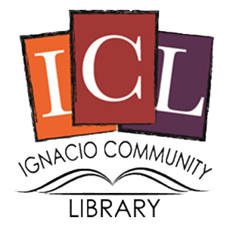
The Ignacio Community Library is a center that brings
people and ideas together for learning and personal growth.

