**IGNACIO COMMUNITY LIBRARY**

**MEETING NOTICE/AGENDA**

**The Ignacio Community Library District Board of Trustees will conduct their regular meeting on July 16, 2025 at 6:00 p.m. at the Ignacio Community Library, 470 Goddard Ave. Ignacio, CO. The public is invited and encouraged to attend.**

1. Call to Order
2. Roll Call
3. Approval of Agenda
4. Approval of Minutes
5. Public Input
6. Unfinished Business
   1. Bylaws Review
   2. Policy Review
      1. Travel Policy
      2. Patron Rules of Conduct
      3. Seasonal Art Exhibit
7. New Business
8. Director’s Report
9. Financial Report
10. Open Discussion
11. Adjournment

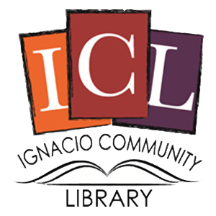

The Ignacio Community Library is a center that brings   
people and ideas together for learning and personal growth.