IGNACIO COMMUNITY LIBRARY
MEETING NOTICE/AGENDA
March 20, 2024
The Ignacio Community Library District Board of Trustees will conduct their regular meeting on March 21. 2024 at 6:00 p.m. at the Ignacio Community Library, 470 Goddard Ave. Ignacio, CO. The public is invited and encouraged to attend.
- Call to Order
- Roll Call
- Approval of Agenda
- Approval of Minutes
- Public Input
- Unfinished Business
  - Marcia’s leave
- New Business
  - Audit Exemption Request
  - Employee Benefits: Leave Time Accrual/Sick Leave
- Director’s Report
- Financial Report
- Open Discussion
- Adjournment
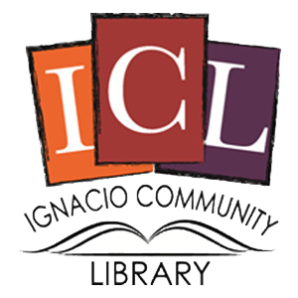
The Ignacio Community Library is a center that brings
people and ideas together for learning and personal growth.

