IGNACIO COMMUNITY LIBRARY
MEETING NOTICE/AGENDA
The Ignacio Community Library District Board of Trustees will conduct their regular meeting on November 17th at 6:00 p.m. at the Ignacio Community Library, 470 Goddard Ave. Ignacio, CO or via zoom meeting. Masks will be required for those attending in person.
Zoom link: https://us06web.zoom.us/j/94533356985
The public is invited and encouraged to attend.
- Call to Order
- Roll Call
- Approval of Agenda
- Approval of Minutes
- Public Input
- Unfinished Business
  - 2022 Budget: Public input
- New Business
- Director’s Report
- Financial Report
- Open Discussion
- Adjournment
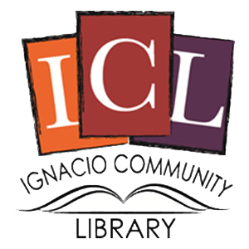
The Ignacio Community Library is a center that brings
people and ideas together for learning and personal growth.

