IGNACIO COMMUNITY LIBRARY
MEETING NOTICE/AGENDA
October 2021

The Ignacio Community Library District Board of Trustees will conduct their
regular meeting on October 20, 2021 at 6:15 p.m. at the Ignacio Community Library, 470 Goddard Ave. Ignacio, CO or via Zoom meeting: https://us06web.zoom.us/j/94533356985

The public is invited and encouraged to attend.

- Call to Order
- Roll Call
- Approval of Agenda
- Approval of Minutes
- Public Input
- Unfinished Business
- New Business
  - 2022 Budget
  - Staff Christmas bonus
  - Bookmobile
- Director’s Report
- Financial Report
- Open Discussion
- Adjournment

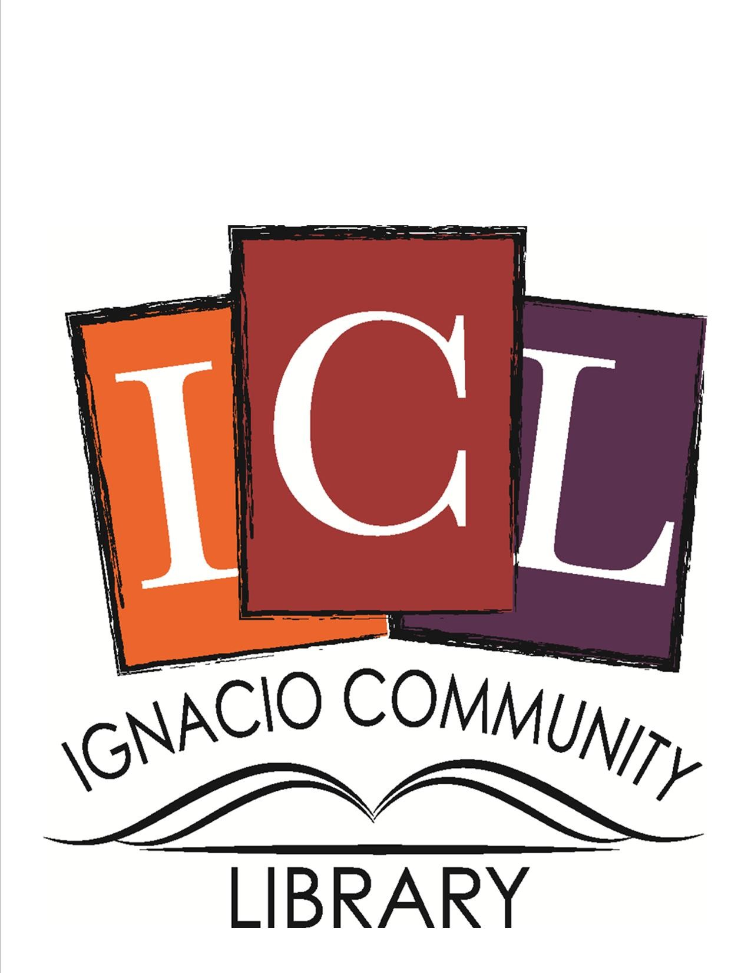

The Ignacio Community Library is a center that brings people
and ideas together for learning and personal growth.

