­­­­­
IGNACIO COMMUNITY LIBRARY
MEETING NOTICE/AGENDA

The Ignacio Community Library District Board of Trustees will conduct their
regular meeting on Sept. 15, 2021 at 6:00 p.m. at the Ignacio Community Library, 470 Goddard Ave. Ignacio, CO. The public is invited and encouraged to attend.

- Call to Order
- Roll Call
- Approval of Agenda
- Approval of Minutes
- Public Input
- Unfinished Business
  - Payroll Discussion
  - Naoma Jones Memorial Date: October 8th @ pm.
- New Business
- Director’s Report
- Financial Report
- Open Discussion
- Adjournment

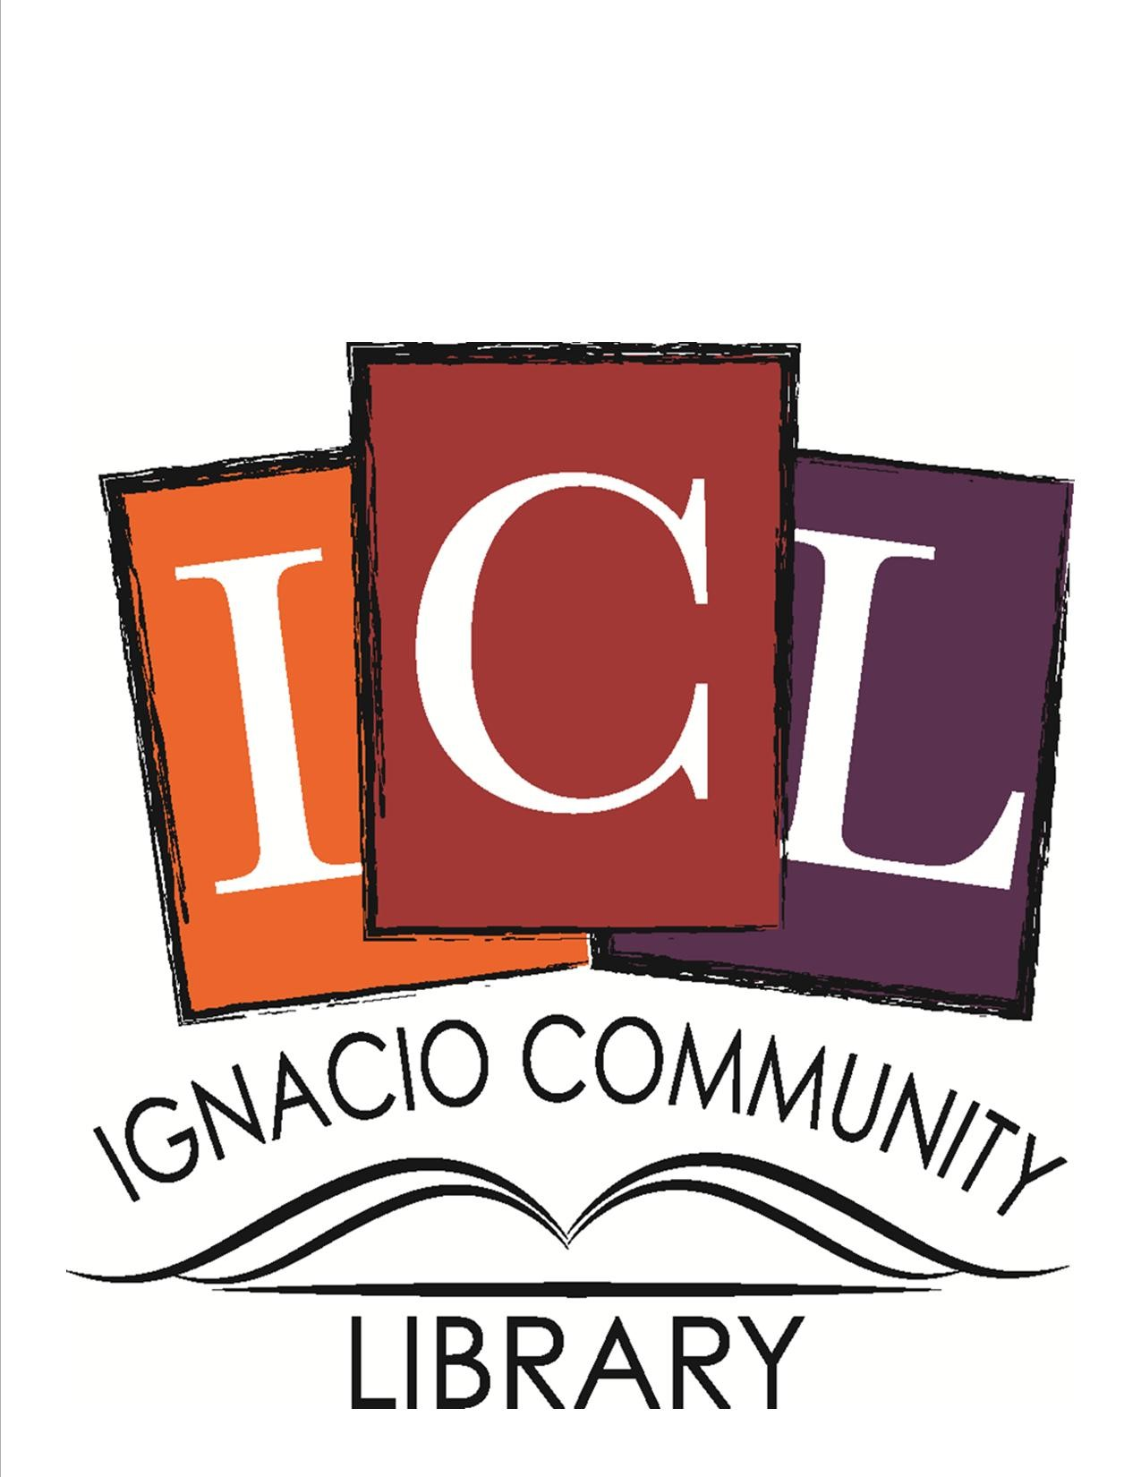

The Ignacio Community Library is a center that brings people
and ideas together for learning and personal growth.

